KENWOOD D-STAR

Press release 28 June 2007
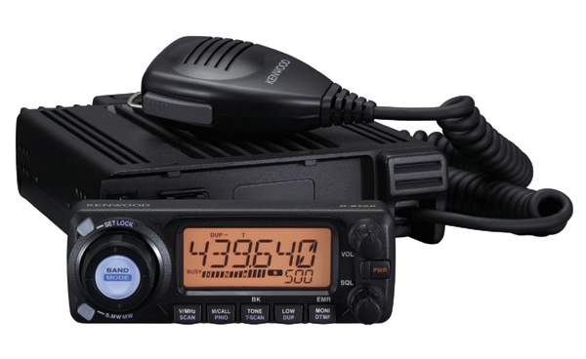
This new release "TMW - 706S" "TMW - 706", this corresponds to a D-STAR, as well as conventional analog FM mode is also available 144/430 MHz band DYUARUBANDA our internet shop "Kenwood ec direct "only as a model release. AVAILABLE ONLY IN JAPAN.

http://translate.google.com/translate?hl=en&sl=ja&u=http://www.kenwood.com/newsrelease/2007/20070628.html&sa=X&oi=translate&resnum=1&ct=result&prev=/search%3Fq%3Dsite:www.kenwood.com%2Bd-star%26num%3D50%26hl%3Den%26safe%3Dactive%26sa%3DG

